Start PacketTracer.

Click Components then Boards (should be selected by default if this is the first time) and add an SBC to the workspace.

F,{aec58021-dcf7-4458-bf45-0c09102def92}{38},9.375,5.333333

Rename it to SBC1.

Click the Programming tab.

Create a **new project** by clicking New.

Set the project name to be **Lab 1-2-1**

Select the Blink - Python template. You will use this code as a starting point.

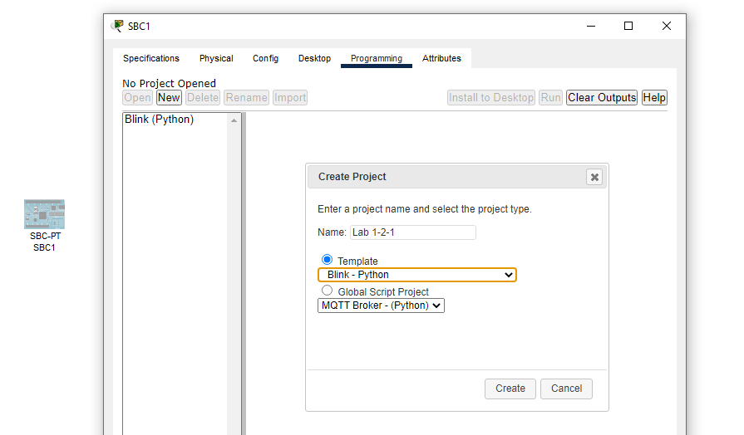

Click Create.

Navigate to main.py.

Click Components then Actuators and drag an LED onto the workspace.

Click Connections, select an IoT custom cable and connect port D0 on the SBC to D0 on the LED.

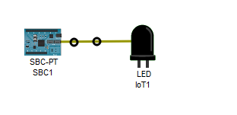

Click the SBC, click the Programming tab, then click Run.

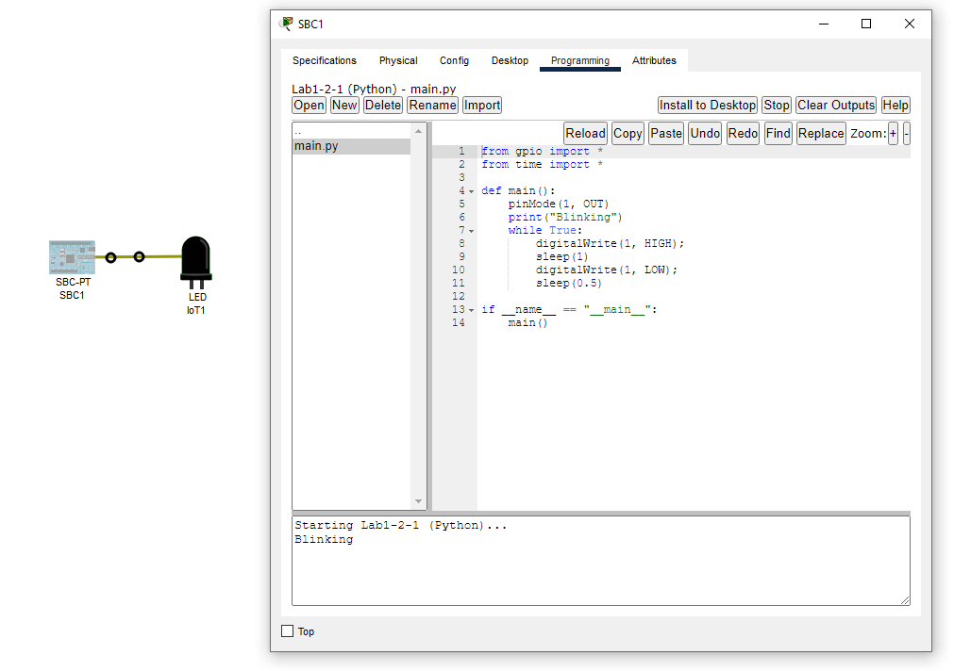

The console will say Blinking. Is the LED blinking? Why? Without changing the cable or connection, make the led blink.

Click Components then Actuators and drag an LCD onto the workspace.

Click Connections, select an IoT custom cable and connect port D1 on the SBC to D0 on the LCD.

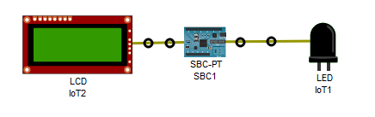

In PacketTracer, select Help/Contents from the menu.

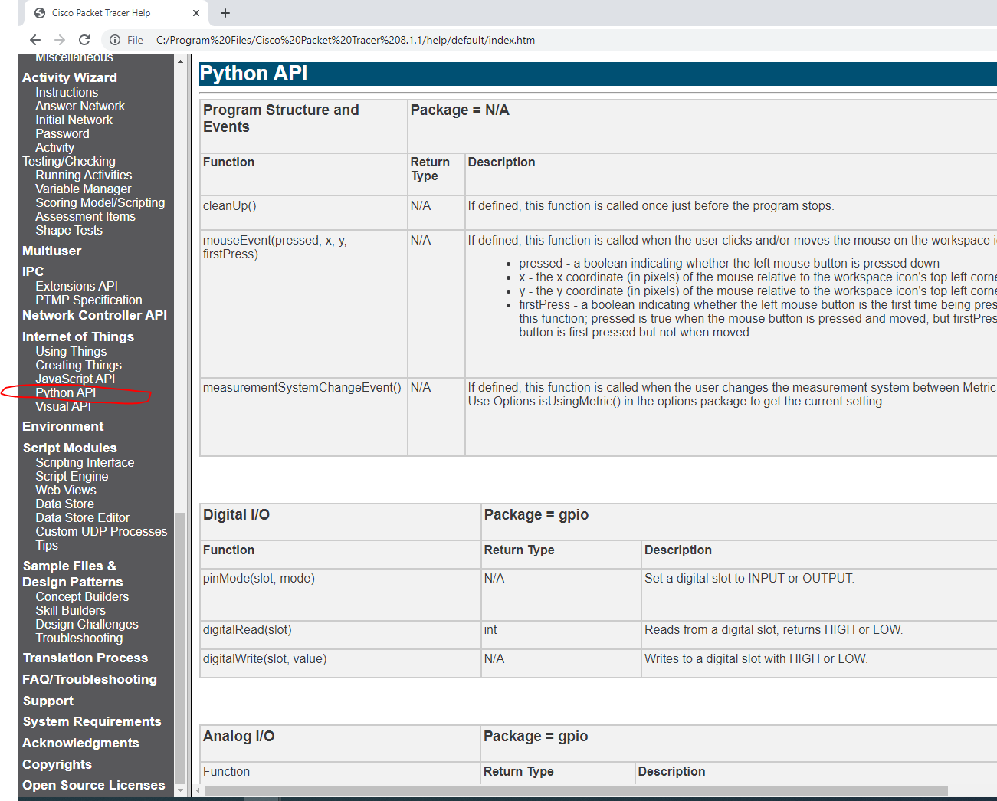

Find

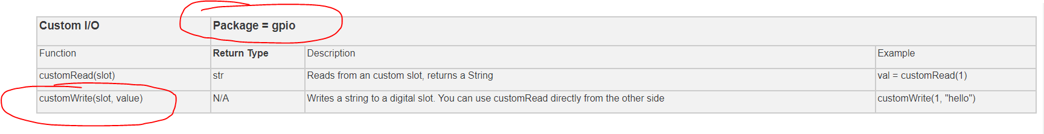

You will need to make use of the customWrite function from the gpio module. Does the current code import the gpio module? If so, which functions need it?

Modify the code so it alternates between blank message and unlit led and the lcd displaying the message 'Blinking' and the led being illuminated.

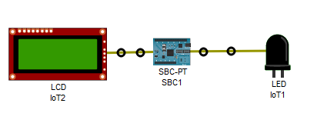

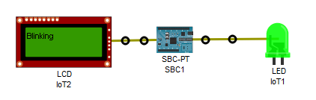

Click Components then Sensors and drag a "Toggle Push Button" (not "Push Button") onto the workspace.

Click Connections, select an IoT custom cable and connect port D2 on the SBC to D0 on the toggle push button.

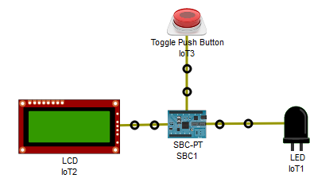

Make use of the digitalRead function for reading the status of the switch

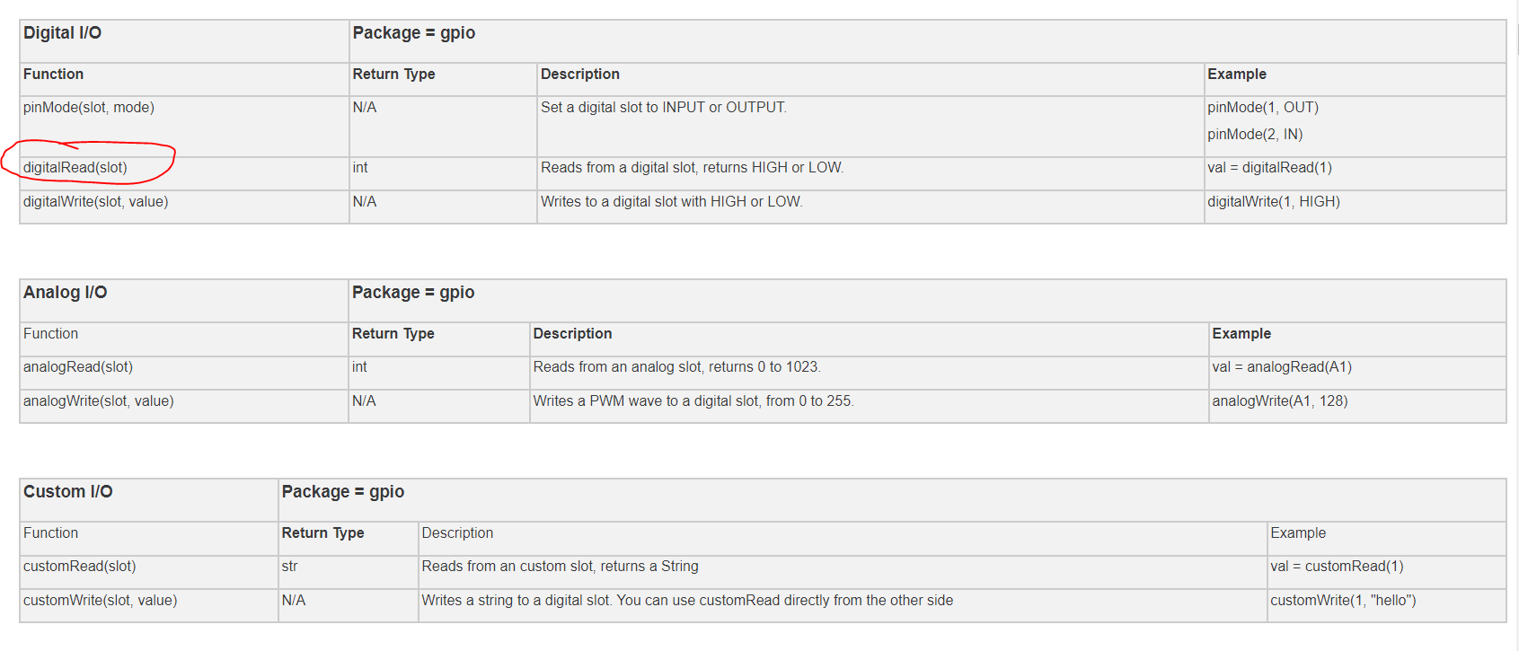

and modify the code so that the message and led are flashed (repeated sequence of message visible, led on then no message, led off) when the button is in the on state and not flashing (no message, led off) when it is in the off state.

You click the button by simultaneously pressing the Alt key and clicking the left mouse button.

This is the button in the off state

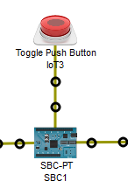

This is the button in the on state

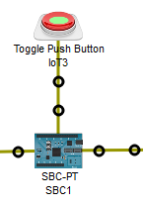

With the button pressed, the LCD and LED alternate between the following states:

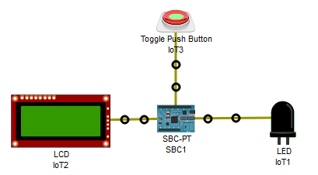

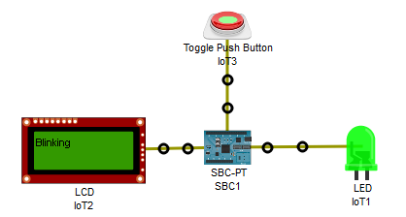

To stop the sequence, Alt click the button.

* The port numbers must be represented using appropriate objects, not magic numbers.
* All functions must have an appropriately worded docstring.
* Code must be commented where appropriate.

Name you PacketTracer file as **Lab1-2-1YourFullName.pkt** and upload it below.

L